| **Unit** | **CQL Definition** | **Examples** |
| --- | --- | --- |
| Year | Defined as the duration of any time interval which starts at a certain time of day at a certain calendar date of the calendar year and ends at:   * The same time of day on the same calendar date of the next calendar year, if it exists * The same time of day on the immediately following calendar date of the next calendar year, if the same calendar date of the next calendar year does not exist.   **Note:** When in the next calendar year the same calendar date does not exist, the ISO states that the ending calendar day has to be agreed upon. The above convention is used in CQL as a resolution to this issue. | Month (date 2) < month (date 1): Duration (years) = year (date 2) - year (date 1) - 1  **Example 1:** Date 1: 2012-**03**-10 22:05:09 Date 2: 2013-**02**-18 19:10:03 Duration = year (date 2) - year (date 1) - 1 = 2013 - 2012 - 1 = **0 years**   1. Month (date 2) = month (date 1) and day (date 2) >= day (date 1) Duration (years) = year (date 2) - year (date 1)   **Example 2.a:** day (date 1) = day (date 2) Date 1: 2012-03-**10** 22:05:09 Date 2: 2013-03-**10** 22:05:09 Duration = year (date 2) - year (date 1) = 2013 - 2012 = **1 year**  ***Note:****Time of day is important in this calculation. If the time of day of Date 2 were less than the time of day for Date 1, the duration of the time interval would be 0 years according to the definition.*  **Example 2.b:** day (date 2) > day (date 1) Date 1: 2012-03-10 22:05:09 Date 2: 2013-03-20 04:01:30 Duration = year (date 2) - year (date 1) = 2013 - 2012 = **1 year**   1. Month (date 2) = month (date 1) and day (date 2) < day (date 1) Duration (years) = year (date 2) - year (date 1) - 1   **Example 3.a:** Date 1: 2012-02-29 Date 2: 2014-02-28 Duration = year (date 2) - year (date 1) - 1 = 2014 - 2012 - 1 = **1 year**   1. Month (date 2) > month (date 1) Duration (years) = year (date 2) - year (date 1)   **Example 4.a:** Date 1: 2012-*03*-10 11:16:02 Date 2: 2013-*08*-15 21:34:16 Duration = year (date 2) - year (date 1) = 2013 - 2012 - **1 year**  **Example 4.b:** Date 1: 2012-*02*-29 10:18:56 Date 2: 2014-*03*-01 19:02:34 Duration = year (date 2) - year (date 1) = 2014 - 2012 = **2 years**  ***Note:****Because there is no February 29 in 2014, the number of years can only change when the date reaches March 1, the first date in 2014 that surpasses the month and day of date 1 (February 29).* |
| Month | Defined as the duration of any time interval which starts at a certain time of day at a certain calendar day of the calendar month and ends at:   * The same time of day at the same calendar day of the ending calendar month, if it exists * The same time of day at the immediately following calendar date of the ending calendar month, if the same calendar date of the ending month in the ending year does not exist.   **Notes:** When in the next calendar year the same calendar date does not exist, the ISO states that the ending calendar day has to be agreed upon. The above convention is used in CQL as a resolution to this issue. | Day (date 2) >= day (date 1) Duration (months) = (year (date 2) - year (date 1)) * 12 + (month (date 2) - month (date 1))  **Example 1.a:** Date 1: 2012-03-01 14:05:45 Date 2: 2012-03-31 23:01:49 Duration = (year (date 2) - year (date 1)) * 12 + (month (date 2) - (month (date 1)) = (2012 - 2012) * 12 + (3 - 3) = **0 months**  **Example 1.b:** Date 1: 2012-03-10 22:05:09 Date 2: 2013-06-30 13:00:23 Duration = (year (date 2) - year (date 1)) * 12 + (month (date 2) - (month date 1)) = (2013 - 2012) * 12 + (6 - 3) = 12 + 3 = **15 months**   1. Day (day 2) < day (date 1) Duration (months) = (year (date 2) - year (date 1)) * 12 + (month (date 2) - month (date 1)) - 1   **Example 2:** Date 1: 2012-03-10 22:05:09 Date 2: 2013-01-09 07:19:33 Duration = (year (date 2) - year (date 1)) * 12 + (month (date 2) - month (date 1)) - 1 = (2013 - 2012) * 12 + (1 - 3) - 1 = 12 - 2 - 1 = **9 months** |
| Weeks | Defined as a duration of any time interval which starts at a certain time of day at a certain calendar day at a certain calendar week and ends at the same time of day at the same calendar day of the ending calendar week. In other words, a complete week is always seven days long. | Duration = [date 2 - date 1 (days)] / 7  **Example 1:** Date 1: 2012-03-10 22:05:09 Date 2: 2012-03-20 07:19:33 Duration = [# days (month (date 1)) - day (date 1) + # days (month (date 1) + 1) + #days (month (date 1) + 2) + ... + # days (month (date 2) - 1) + day (date 2)] / 7 = (20 - 10) / 7 = 10 / 7 = **1 week** |
| Days | Defined as a duration of any time interval which starts at a certain calendar day and ends at the next calendar day (1 second to 23 hours, 59 minutes, and 59 seconds).  The duration in days between two dates will generally be given by subtracting the start calendar date from the end calendar date, respecting the time of day between the two dates. | Time (date 2) < time (date 1) Duration = [date 2 - date 1 (days)] - 1  **Example 1:** Date 1: 2012-01-31 12:30:00 Date 2: 2012-02-01 09:00:00 Duration = 02-01 - 01-31 - 1 = **0 days**   1. Time (date 2) >= time (date 1) Duration = date 2 - date 1 (days)   **Example 2:** Date 1: 2012-01-31 12:30:00 Date 2: 2012-02-01 14:00:00 Duration = 02-01 - 01-31 = **1 day** |
| Hours | Defined as 60 minutes  The duration in hours between two dates is the number of minutes between the two dates, divided by 60. The result is truncated to the unit. | **Example 1:** Date 1: 2012-03-01 03:10:00 Date 2: 2012-03-01 05:09:00 Duration = **1 hour**  **Example 2:** Date 1: 2012-02-29 23:10:00 Date 2: 2012-03-01 00:10:00 Duration = **1 hour**  **Example 3:** Date 1: 2012-03-01 03:10 Date 2: 2012-03-01 04:00 Duration = **0 hours** |
| Minutes | Defined as 60 seconds  The duration in minutes between two dates is the number of seconds between the two dates, divided by 60. The result is truncated to the unit. | **Example 1:** Date 1: 2012-03-01 03:10:00 Date 2: 2012-03-01 05:20:00 Duration = **130 minutes**  **Example 2:** Date 1: 2012-02-29 23:10:00 Date 2: 2012-03-01 00:20:00 Duration = **70 minutes** |

Interval Comparisons:

CQL provides a complete set of interval comparison operators:

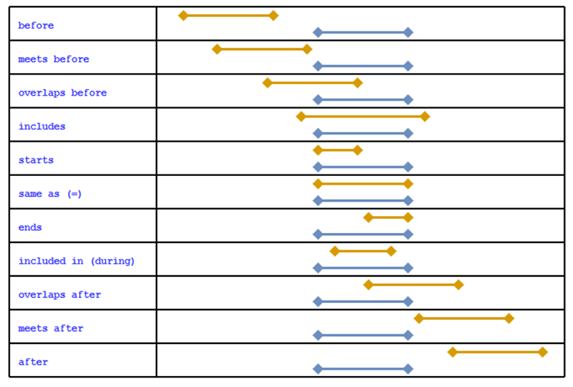

**Timing Phrases**

CQL also supports timing phrases that make it easier to express precise relationships between intervals using natural language. The before and after operators can have a prefix ofstartsorends, and a suffix ofstartorend`. For example:

IntervalX starts before start IntervalY

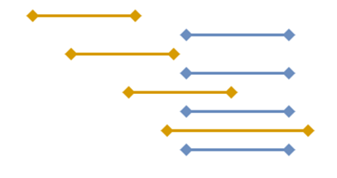

The before and after operators can also take an offset that indicates how far away a given relationship should be. The offset can be absolute, indicating that the boundary of the interval must be on the offset, or it can be relative, indicating that the boundary must be at least on the offset:

IntervalX starts 3 days before start IntervalY

IntervalX starts 3 days or more before start IntervalY

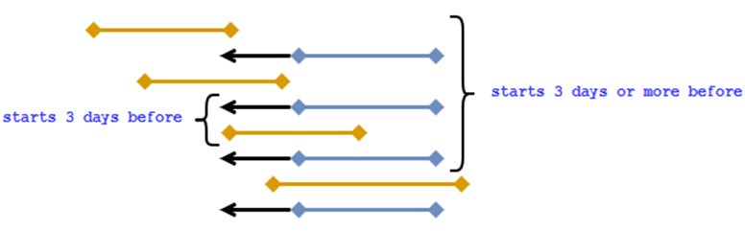

You can also specify a range for the boundary relationship using the within..of operator:

IntervalX starts within 3 days of start IntervalY

